 | 16.1.8 Editors - Dope Sheet - Action Menu
Table of content
Dopesheet Editor - Key Menu 1
Merge Animation 1
Separate Slots 1
Move Slots to new Action 1

Dopesheet Editor - Key Menu

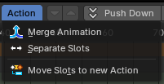
Just in Action Editor mode.

Merge Animation
Merge the animation of the selected objects into the action of the active object. Actions are not deleted by this. But might end up with zero users.

Separate Slots
Move all sots of thea ction on the active object into newly created, separate actions. All users of those slots will be reassigned to the new actions. The current action won't be deleted. But will be empty. And might end up with zero users.

Move Slots to new Action
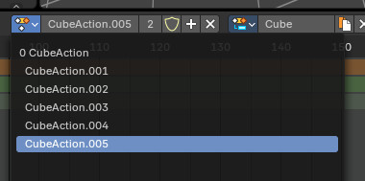
Move the selected slots into a newly created action.

